CS221 ASSIGNMENT

NAME-MESHARYA M CHOUDHARY

ROLL NO.-190101053

The folder has High Level Design,Low Level Design and their respective Testbenches.

High Level Design utilizes this state diagram

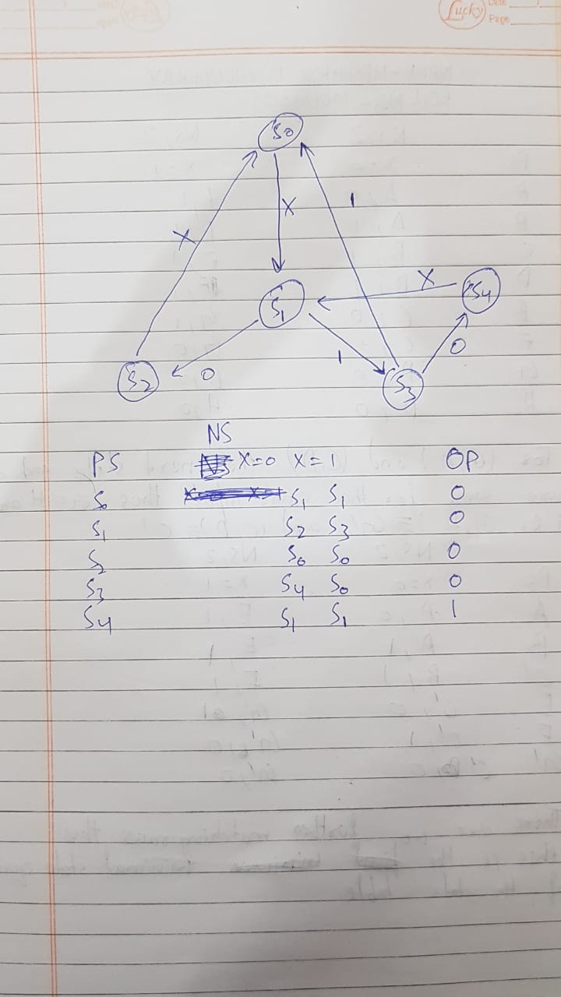

Low Level Design utilizes a D flip flop module(named DFF) that stores the value obtained after simplifying the logic of the next state and the output using K-Map.

D0= (~Q2 & ~Q1) | (~Q0 & ~Q2);

D1= (~Q2 & ~Q1 & Q0 & x) | (~Q2 & Q1 & Q0 & ~x);

D2= ~Q2 & ~Q1 & Q0 & ~x;

out=~Q2 & Q1 & ~Q0;

where Q is the Present State and D(Next State and D expressions are same in case of D Flip Flop) is the next state.

x is the input and out is the output

The outputs for the verilog code is attached.Compiler used is EDAPlayground which is an online verilog compiler.

After every three input we check if output is 1.If it is then we say that a match was found else we say it wasn’t found.

These are the photos of the output for low level and high level implementations.

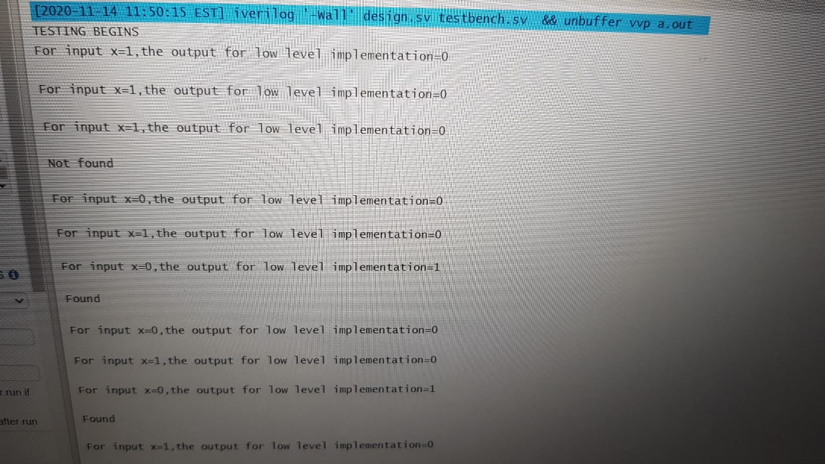

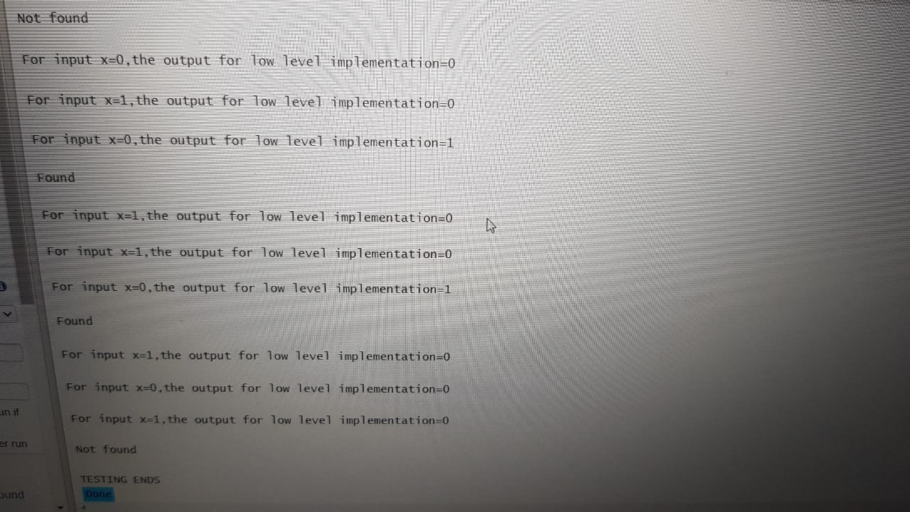

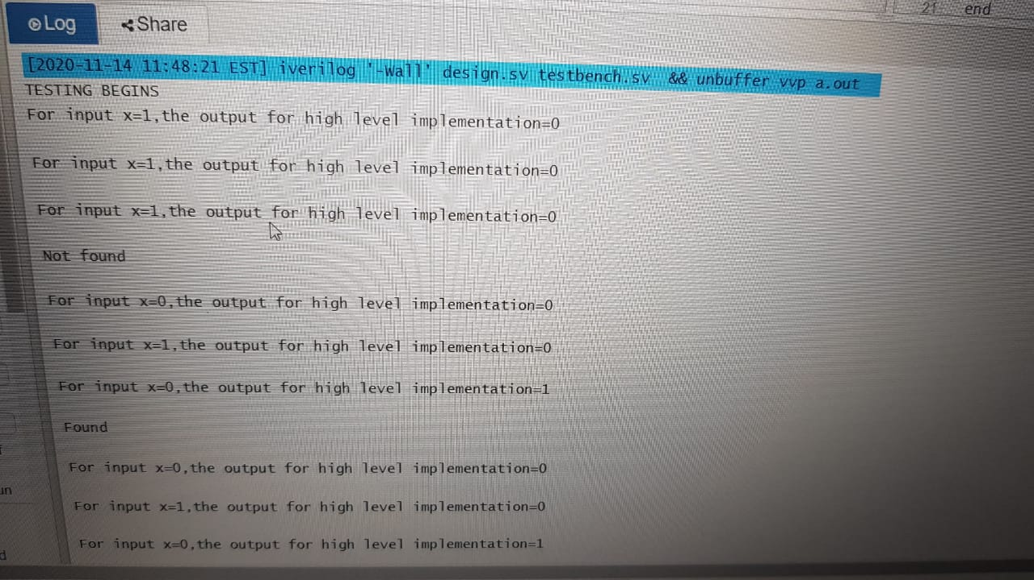

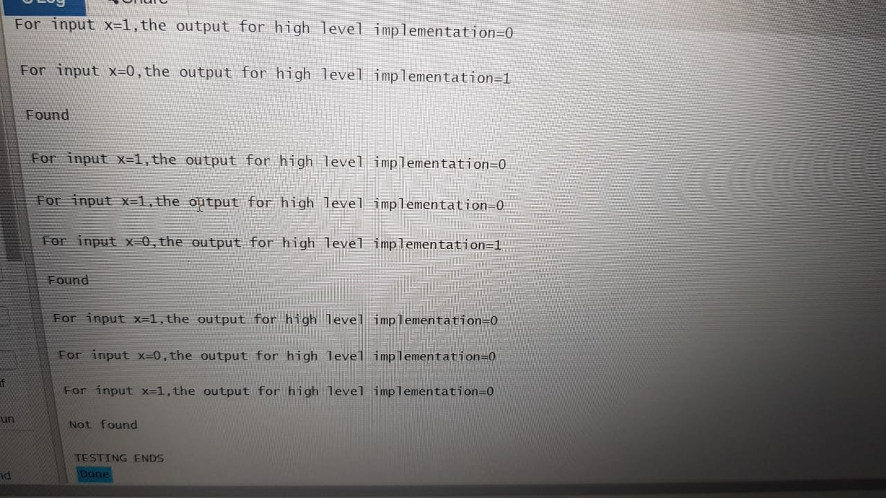

This is the full output given by the compiler for high level implementation.

TESTING BEGINS  
For input x=1,the output for high level implementation=0  
  
For input x=1,the output for high level implementation=0  
  
For input x=1,the output for high level implementation=0  
  
Not found  
  
For input x=0,the output for high level implementation=0  
  
For input x=1,the output for high level implementation=0  
  
For input x=0,the output for high level implementation=1  
  
Found  
  
For input x=0,the output for high level implementation=0  
  
For input x=1,the output for high level implementation=0  
  
For input x=0,the output for high level implementation=1  
  
Found  
  
For input x=1,the output for high level implementation=0  
  
For input x=1,the output for high level implementation=0  
  
For input x=0,the output for high level implementation=1  
  
Found  
  
For input x=0,the output for high level implementation=0  
  
For input x=1,the output for high level implementation=0  
  
For input x=0,the output for high level implementation=1  
  
Found  
  
For input x=0,the output for high level implementation=0  
  
For input x=0,the output for high level implementation=0  
  
For input x=0,the output for high level implementation=0  
  
Not found  
  
For input x=1,the output for high level implementation=0  
  
For input x=1,the output for high level implementation=0  
  
For input x=1,the output for high level implementation=0  
  
Not found  
  
For input x=0,the output for high level implementation=0  
  
For input x=1,the output for high level implementation=0  
  
For input x=0,the output for high level implementation=1  
  
Found  
  
For input x=0,the output for high level implementation=0  
  
For input x=0,the output for high level implementation=0  
  
For input x=1,the output for high level implementation=0  
  
Not found  
  
For input x=1,the output for high level implementation=0  
  
For input x=0,the output for high level implementation=0  
  
For input x=0,the output for high level implementation=0  
  
Not found  
  
For input x=1,the output for high level implementation=0  
  
For input x=1,the output for high level implementation=0  
  
For input x=0,the output for high level implementation=1  
  
Found  
  
For input x=1,the output for high level implementation=0  
  
For input x=0,the output for high level implementation=0  
  
For input x=1,the output for high level implementation=0  
  
Not found  
  
For input x=0,the output for high level implementation=0  
  
For input x=1,the output for high level implementation=0  
  
For input x=0,the output for high level implementation=1  
  
Found  
  
For input x=1,the output for high level implementation=0  
  
For input x=1,the output for high level implementation=0  
  
For input x=0,the output for high level implementation=1  
  
Found  
  
For input x=1,the output for high level implementation=0  
  
For input x=0,the output for high level implementation=0  
  
For input x=1,the output for high level implementation=0  
  
Not found  
  
TESTING ENDS

This is the full output given by the compiler for low level implementation.

TESTING BEGINS  
For input x=1,the output for low level implementation=0  
  
For input x=1,the output for low level implementation=0  
  
For input x=1,the output for low level implementation=0  
  
Not found  
  
For input x=0,the output for low level implementation=0  
  
For input x=1,the output for low level implementation=0  
  
For input x=0,the output for low level implementation=1  
  
Found  
  
For input x=0,the output for low level implementation=0  
  
For input x=1,the output for low level implementation=0  
  
For input x=0,the output for low level implementation=1  
  
Found  
  
For input x=1,the output for low level implementation=0  
  
For input x=1,the output for low level implementation=0  
  
For input x=0,the output for low level implementation=1  
  
Found  
  
For input x=0,the output for low level implementation=0  
  
For input x=1,the output for low level implementation=0  
  
For input x=0,the output for low level implementation=1  
  
Found  
  
For input x=0,the output for low level implementation=0  
  
For input x=0,the output for low level implementation=0  
  
For input x=0,the output for low level implementation=0  
  
Not found  
  
For input x=1,the output for low level implementation=0  
  
For input x=1,the output for low level implementation=0  
  
For input x=1,the output for low level implementation=0  
  
Not found  
  
For input x=0,the output for low level implementation=0  
  
For input x=1,the output for low level implementation=0  
  
For input x=0,the output for low level implementation=1  
  
Found  
  
For input x=0,the output for low level implementation=0  
  
For input x=0,the output for low level implementation=0  
  
For input x=1,the output for low level implementation=0  
  
Not found  
  
For input x=1,the output for low level implementation=0  
  
For input x=0,the output for low level implementation=0  
  
For input x=0,the output for low level implementation=0  
  
Not found  
  
For input x=1,the output for low level implementation=0  
  
For input x=1,the output for low level implementation=0  
  
For input x=0,the output for low level implementation=1  
  
Found  
  
For input x=1,the output for low level implementation=0  
  
For input x=0,the output for low level implementation=0  
  
For input x=1,the output for low level implementation=0  
  
Not found  
  
For input x=0,the output for low level implementation=0  
  
For input x=1,the output for low level implementation=0  
  
For input x=0,the output for low level implementation=1  
  
Found  
  
For input x=1,the output for low level implementation=0  
  
For input x=1,the output for low level implementation=0  
  
For input x=0,the output for low level implementation=1  
  
Found  
  
For input x=1,the output for low level implementation=0  
  
For input x=0,the output for low level implementation=0  
  
For input x=1,the output for low level implementation=0  
  
Not found  
  
TESTING ENDS